## General

1. During the build, make sure the build is in **RELEASE** mode.
2. For in office candidate registration page. Add comma separated IP address to “CommonSettings.AllowedIPAddresses” in setting.
   1. North York: 70.28.19.70
   2. Mississauga: 50.100.212.216
   3. Scarborough: 64.228.144.35

## Reports

1. Before deploying the reports, update the **Shared Data Sources’** properties to improve the security:
   1. In Visual Studio, double click on *WFMDataSources.rds* and make sure the connection string is correct.
   2. Click on the ‘Edit’ to access more properties

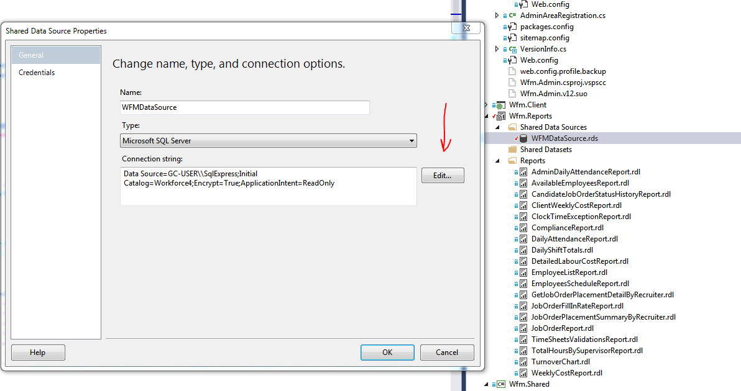

* 1. Click on ‘Advanced’ button

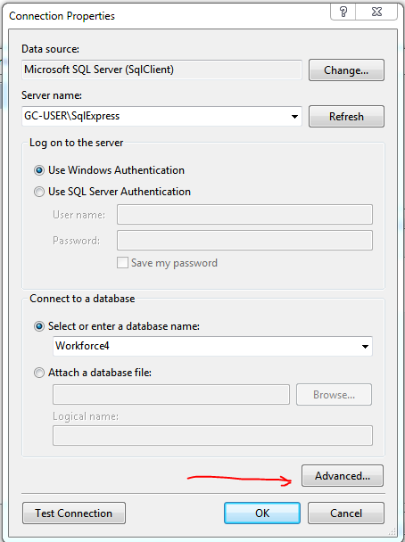

* 1. Set the following property values:
     1. ApplicationIntent = ReadOnly (Default is ReadWrite)
     2. Encrypt = True (Default is False)

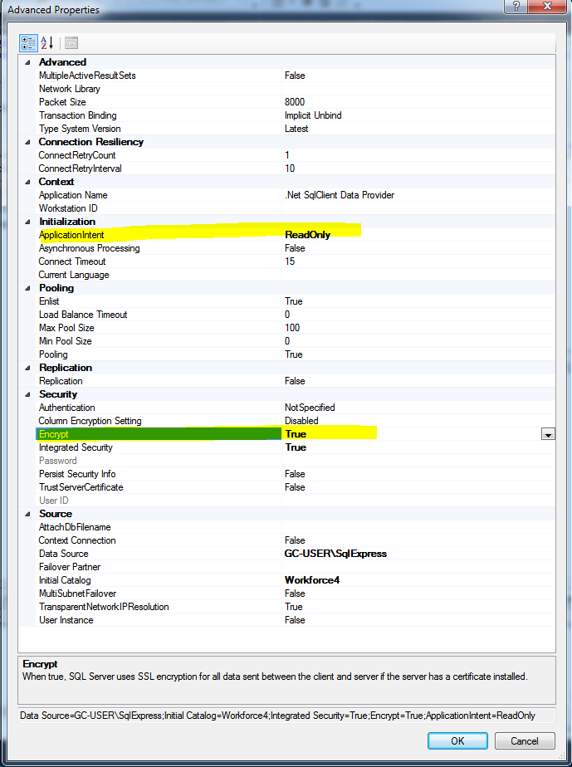

1. Check if Encrypt=True works for HTTPS
2. Deploy reports, including 3 new:
   1. Daily Attendance
   2. Daily Shift Totals by recruiter
   3. Job Order Placements Summary by recruiter

## Smart Card Print

1. Create folder Uploads\Templates
2. Copy following files to the above folder, from folder Templates\SmartCard
   1. Back.xaml
   2. Front.xaml
   3. Logo.png
   4. SmartCard.xml